1. The part number is shown, but the script didn’t write it to the output, instead writing the word “Part”
2. 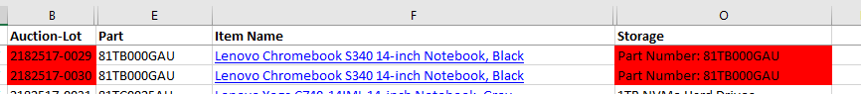Although it contained none of the “Storage” key words, the script wrote the ‘part number’ text to the output.
3. 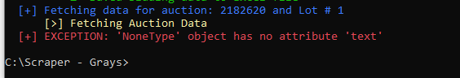The script fails to perform when the auction is still open